**Online Certification Course Details:**

**BLOCKCHAIN BASICS:**

**Today I completed 2 lessons:**

### Hashing

#### Transaction Integrity

**And took quiz on these lessons**

**SNAPSHOTS:**

**Hashing --**

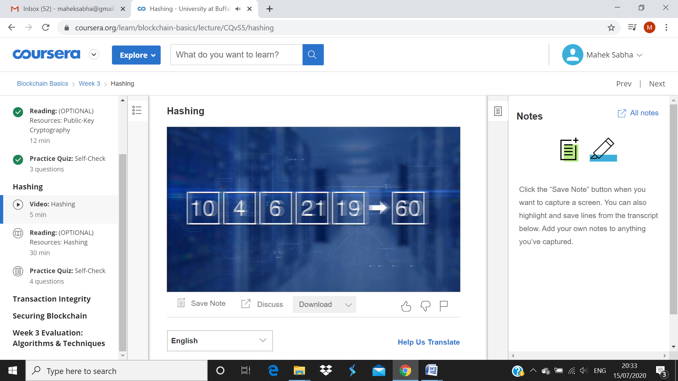

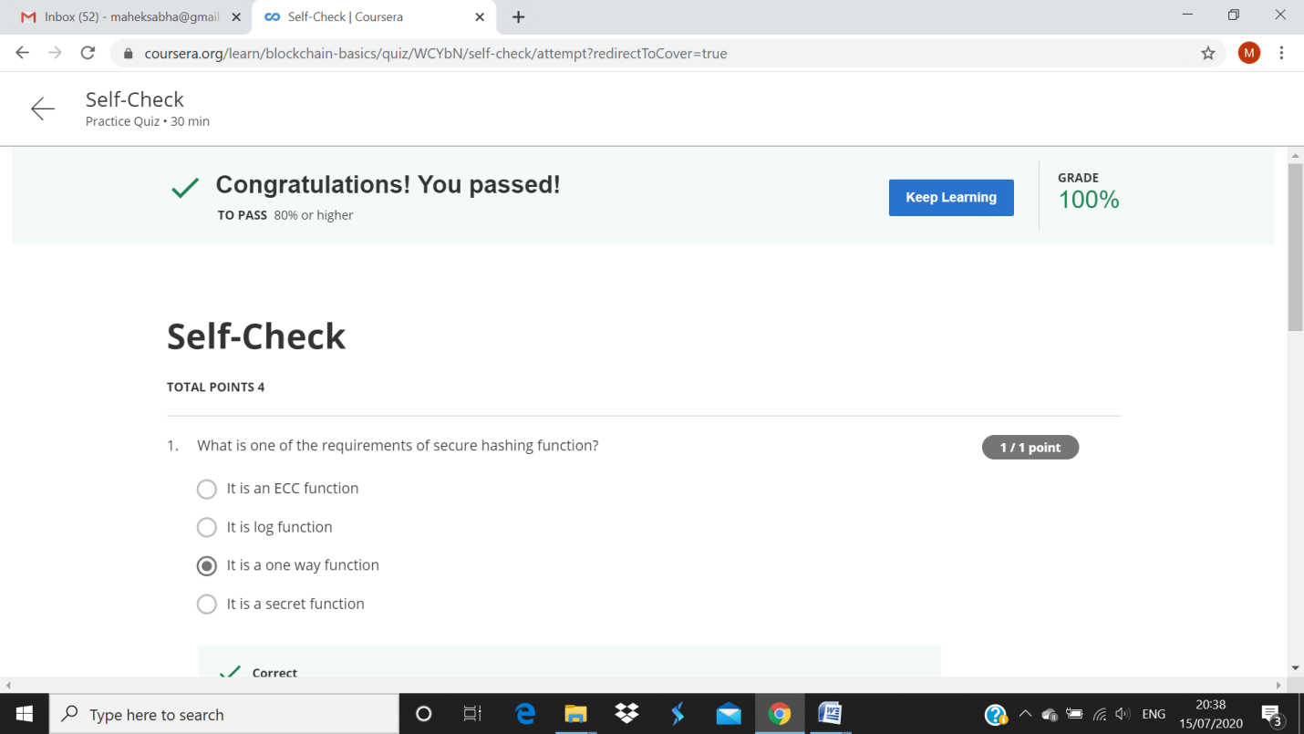

#### Transaction Integrity--

